Data Flow Diagram (DFD) for Restaurant Management System

This document outlines the structure of a full-service Restaurant Management System using Data Flow Diagram notation, focusing on order taking, kitchen fulfillment, and administration.

1. Level 0: Context Diagram

The Context Diagram shows the entire system as a single process and its interaction with external entities.

System:

Restaurant Management System

External Entities (Interacting with the system):

Customer: Places orders (directly or via waiter), receives food/service, pays bills.

Waiter/Server: Takes orders, handles table assignments, manages billing.

Kitchen Staff: Receives preparation tickets, updates order status.

Admin/Manager: Configures menu, views financial reports, manages staff.

Data Flows (Flowing between Entities and the System):

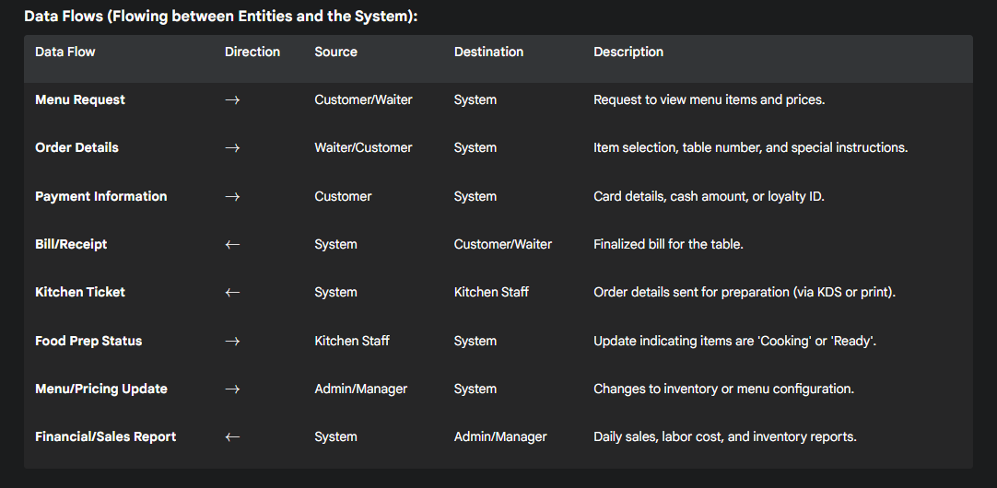

**2. Level 1: First Level Diagram (Decomposition)**

The Level 1 DFD breaks down the main system into its core processes and shows how data flows between them and the data stores.

**Processes:**

* **P1. Handle Order Entry & Table Management (POS)**
* **P2. Manage Kitchen Fulfillment (KDS/Ticket)**
* **P3. Process Payments & Billing**
* **P4. Maintain Menu, Inventory, & Staff**

**Data Stores:**

* **DS1. Menu & Inventory** (Stores current items, prices, stock levels, and recipes.)
* **DS2. Active Orders & Tables** (Stores current table status, active orders, and wait times.)
* **DS3. Transaction Log** (Stores all completed billing data for auditing.)
* **DS4. Staff & Users** (Stores staff credentials, roles, and shift data.)

**Data Flows (Between Processes, Entities, and Stores):**

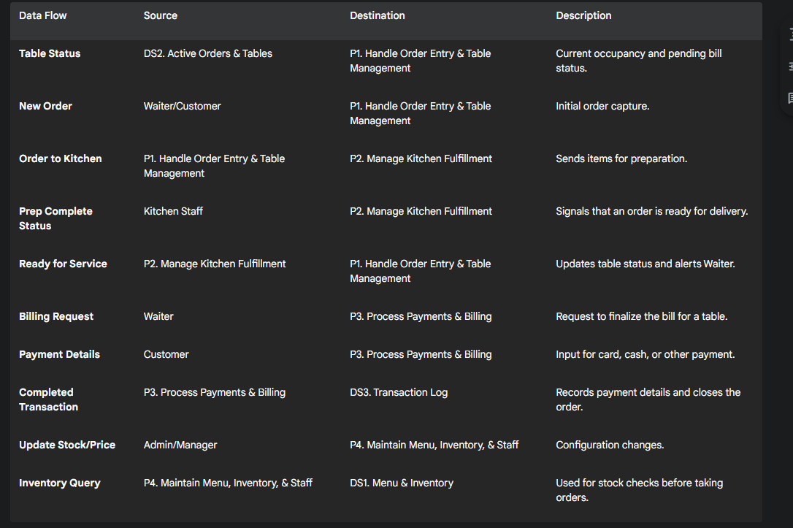

**Entity-Relationship (ER) Model for Restaurant Management System**

This model outlines the primary entities and relationships required to support the functionality described in the Level 1 DFD.

**Entities and Attributes**

**1. STAFF (Roles: Waiter, Kitchen Staff, Admin)**

* **staff_id** (PK, Primary Key)
* first_name
* last_name
* role (e.g., 'Waiter', 'Cook', 'Manager')
* contact_number
* hire_date
* hourly_rate

**2. TABLE**

* **table_id** (PK)
* capacity
* location (e.g., 'Patio', 'Window', 'Bar')
* is_occupied (Boolean)
* status (e.g., 'Waiting for Order', 'Serving', 'Needs Cleaning')

**3. MENU_ITEM**

* **item_id** (PK)
* name
* description
* price
* category (e.g., 'Appetizer', 'Main Course', 'Dessert')
* is_available (Boolean)

**4. INVENTORY**

* **ingredient_id** (PK)
* name
* current_stock
* unit_of_measure (e.g., 'kg', 'liter', 'each')
* min_stock_level

**5. ORDER**

* **order_id** (PK)
* table_id (FK to TABLE)
* staff_id (FK to STAFF - Waiter who took the order)
* order_datetime
* status (e.g., 'Pending', 'In Progress', 'Fulfilled')
* total_amount (Calculated)

**6. TRANSACTION (The final payment record)**

* **transaction_id** (PK)
* order_id (FK to ORDER)
* payment_method (e.g., 'Cash', 'Card', 'Online')
* amount_paid
* tip_amount
* transaction_datetime

**7. ORDER_ITEM (Junction/Line Item Entity for ORDER and MENU_ITEM)**

* **order_item_id** (PK)
* order_id (FK to ORDER)
* item_id (FK to MENU_ITEM)
* quantity
* special_requests (Text field)
* kitchen_status (e.g., 'New', 'Cooking', 'Ready')

**8. RECIPE_INGREDIENT (Junction Entity for MENU_ITEM and INVENTORY)**

* **recipe_ingredient_id** (PK)
* item_id (FK to MENU_ITEM)
* ingredient_id (FK to INVENTORY)
* quantity_needed (How much of the ingredient is needed for one item)